**AWS – CLOUD FRONT**

Amazon cloud front is a web service that gives business and web applications an easy and cost effective way to delivery content with **low latency** and high data transfer rate.

Outside cloud , the same service is called CDN – Content Delivery Network.

Scenario:

* Lets take an example of having one application running on several instances at different regions.
* There will be latency issue when one user is requesting data from one region to instance at another region.
* To improve low latency we can go for auto scaling, but it is costly and there should be data replication or synchronization issues.
* The best solution is provided by cloud front is using ‘Edge locations’.

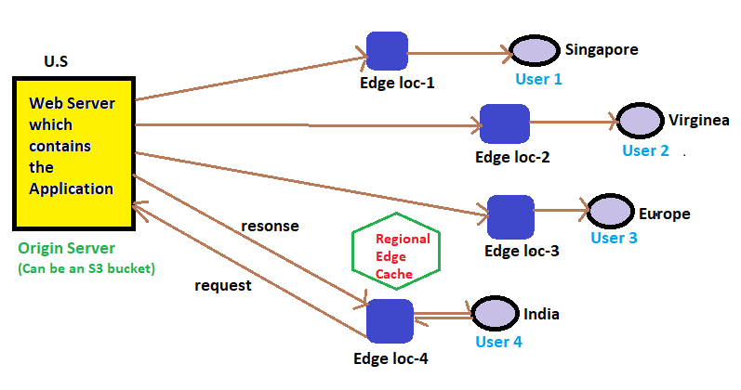

**Edge Location:**

1. Cloud Front delivers your content through a worldwide network of data centers called ‘Edge Locations’. Around 205 Edge Locations are available through out world.
2. Whenever any user requests data that you are searching with CF, the request is routed to the ‘Edge Location’ which provides the lowest latency, so that the data is delivered with upmost performance.
3. The main servers which holds the application is called the ‘Origin Server’.
4. Using Edge Locations it can be possible to lower the latency, cost and reduce Auto Scaling.
5. First request made by the user will reach to Edge Location and the same request is carried forward to the Origin Server. The response from the origin server is ‘stored and at the same time response is forwarded to the user’ by Edge locations.
6. That means Edge Locations stores the response and forwards to the user.
7. This is helpful when the user makes the same request yo the Edge Location, and Edge location immediately responds from itself, without contacting Origin server. Thus saving time(low latency) and fast response time.
8. Edge locations are strongly connected to the origin servers, that even the first response from origin server to Edge Location will be reached very fast.
9. If the data is already in the edge location with the lowest latency, CF delivers it immediately.
10. If the data asked is not available from the Edge Location, than Edge location retrieves the requested data from Web Server or S3 bucket or any other server that you have identified as the source for the definitive version (Origin Server) of your content.
11. CF keeps persistent (constant) connection from the Origin Server, so that data is fetched from Origin Server ASAP.

**Ways of Accessing Cloud Front (CF):**

1. AWS management Console.
2. AWS SDK’s.
3. Cloud Front API.
4. AWS CLI

|  |  |
| --- | --- |
| **Cloud Front - Edge Locations** | **Cloud Front – Regional Edge Cache** |
| * Edge Locations are not tied to AZ’a or Regions. Which means you cannot directly control them. | * AWS CF has added several regional edge cache locations globally at close proximity to users. * They are located between your Origin Server and the Global Edge Locations. |
| * AWS CF has 216 POP (point of presence). * Among them 205 Edge Locations and 11 Regional Edge Caches in 84 cities across 42 countries. | * Whenever the data in the Edge Locations expire after the given period, then such data will be remained in Regional Edge Cache, waiting for future retrieval from the Edge Locations. * This will reduce overload on Origin Servers. * Regional Edge Cache’s have a large cache capacity than any individual Edge Location. So data will remain here for longer periods. |

**NOTE**: Route 53 will direct the request to its destination between User, Edge Location, Origin Server or Regional Edge Cache.

**Feature Parity with Edge Locations:**

1. In Regional Edge Cache, we have this option which is used to remove the data both from Edge Location and Regional Edge Cache before the expiry period.
2. In such cases, if the user makes a request to get the same deleted data, than that data this time will be retrieved from Origin Server.
3. But, this time latest updated data will be served.
4. This is useful when ever you update your website or application, and you want those updated need to be executed in the user system.

**NOTE**: If you are using a proxy method like PUT/POST/PATCH/OPTIONS/DELETE, then those requests will directly go to the Origin Server from the edge locations, but not through the Regional Edge Cache. The same applies for Dynamic Content.